Entity-Relationship Diagram (ERD)

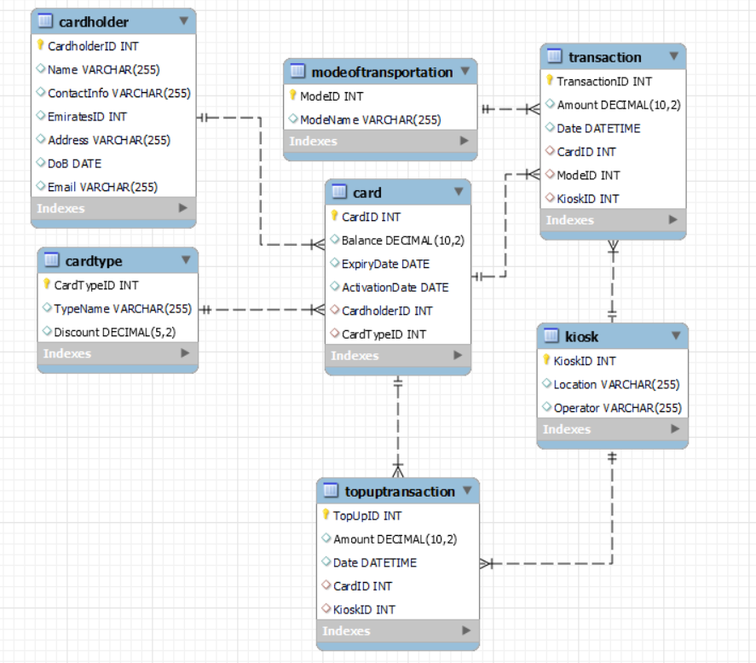

CODE:

CREATE TABLE Cardholder (

    CardholderID INT PRIMARY KEY,

    Name VARCHAR(255),

    ContactInfo VARCHAR(255),

    EmiratesID INT,

    Address VARCHAR(255),

    DoB DATE,

    Email VARCHAR(255) );

CREATE TABLE CardType (

    CardTypeID INT PRIMARY KEY,

    TypeName VARCHAR(255),

    Discount DECIMAL(5,2) -- Discount percentage (e.g., 0.5 for 50% off) );

CREATE TABLE Card (

    CardID INT PRIMARY KEY,

    Balance DECIMAL(10, 2),

    ExpiryDate DATE,

    ActivationDate DATE,

    CardholderID INT,

    CardTypeID INT,

    FOREIGN KEY (CardholderID) REFERENCES Cardholder(CardholderID),

    FOREIGN KEY (CardTypeID) REFERENCES CardType(CardTypeID) );

CREATE TABLE Kiosk (

    KioskID INT PRIMARY KEY,

    Location VARCHAR(255),

    Operator VARCHAR(255) );

CREATE TABLE ModeOfTransportation (

    ModeID INT PRIMARY KEY,

    ModeName VARCHAR(255) );

CREATE TABLE Transaction (

    TransactionID INT PRIMARY KEY,

    Amount DECIMAL(10, 2),

    Date DATETIME DEFAULT NOW(), -- Default to current timestamp

    CardID INT,

    ModeID INT,

    KioskID INT,

    FOREIGN KEY (CardID) REFERENCES Card(CardID),

    FOREIGN KEY (ModeID) REFERENCES ModeOfTransportation(ModeID),

    FOREIGN KEY (KioskID) REFERENCES Kiosk(KioskID)

);

CREATE TABLE TopUpTransaction (

    TopUpID INT PRIMARY KEY,

    Amount DECIMAL(10, 2) DEFAULT 0, -- Default value set to 0

    Date DATETIME DEFAULT NOW(),

    CardID INT,

    KioskID INT,

    FOREIGN KEY (CardID) REFERENCES Card(CardID),

    FOREIGN KEY (KioskID) REFERENCES Kiosk(KioskID)

);

TABLE DESCRIPTION:

Cardholder Table:

* This table stores information about cardholders.
* Attributes include CardholderID (primary key), Name, ContactInfo, EmiratesID, Address, Date of Birth (DoB), and Email.

CardType Table:

* This table stores information about card types.
* Attributes include CardTypeID (primary key), TypeName, and Discount.
* Discount represents the discount percentage applicable to the card type.

Card Table:

* This table stores information about cards issued to cardholders.
* Attributes include CardID (primary key), Balance, ExpiryDate, ActivationDate, CardholderID (foreign key referencing Cardholder table), and CardTypeID (foreign key referencing CardType table).

Kiosk Table:

* This table stores information about kiosks where transactions take place.
* Attributes include KioskID (primary key), Location, and Operator.

ModeOfTransportation Table:

* This table stores information about modes of transportation.
* Attributes include ModeID (primary key) and ModeName.

Transaction Table:

* This table stores information about transactions made by cardholders.
* Attributes include TransactionID (primary key), Amount, Date, CardID (foreign key referencing Card table), ModeID (foreign key referencing ModeOfTransportation table), and KioskID (foreign key referencing Kiosk table).

TopUpTransaction Table:

* This table stores information about top-up transactions.
* Attributes include TopUpID (primary key), Amount, Date, CardID (foreign key referencing Card table), and KioskID (foreign key referencing Kiosk table).

Queries:

SELECT * from nol_card.card WHERE CardholderID = 1003

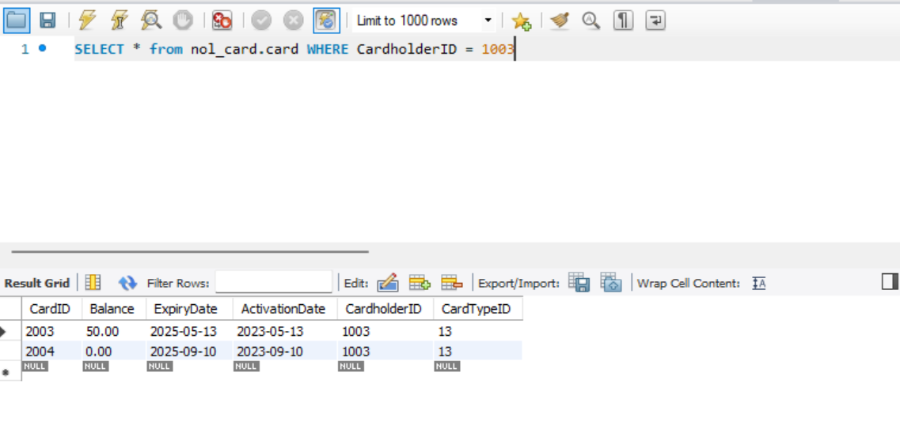

SELECT CardID, Balance FROM nol_card.card;

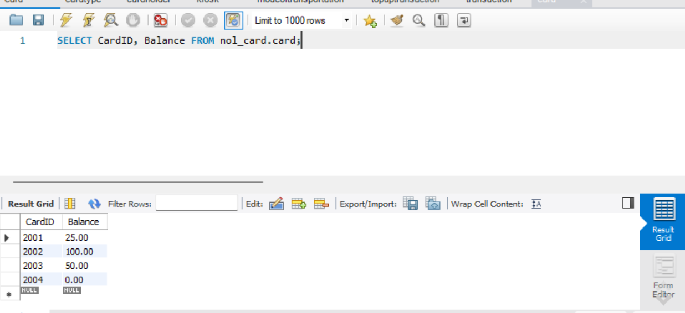

SELECT * FROM nol_card.transaction WHERE Date < '2025-01-01' and ModeID = 1717;

UPDATE Card

SET Balance = Balance - (10 * (SELECT Discount FROM CardType WHERE TypeName = 'Student'))

WHERE CardID = 2002;

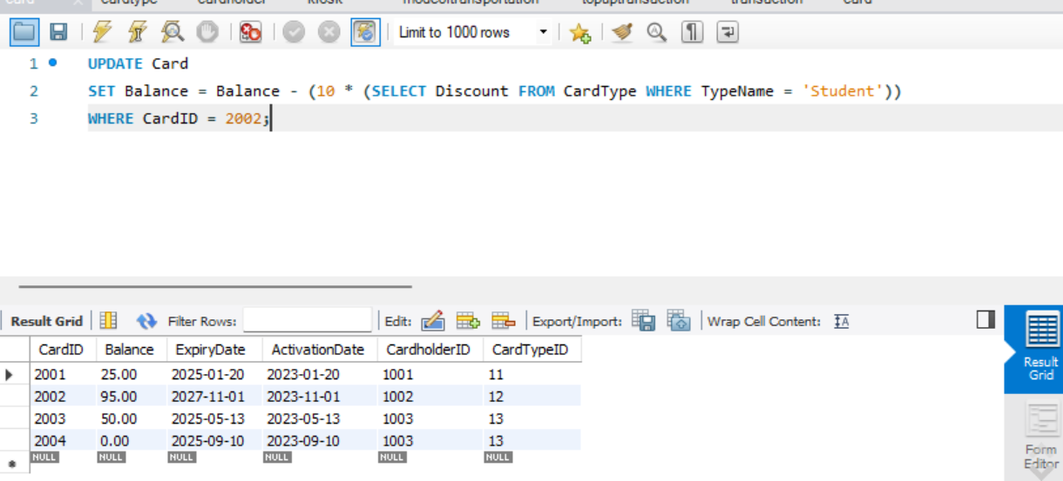

SELECT

    10 * (SELECT Discount FROM CardType WHERE TypeName = 'Student') AS Amount,

    NOW() AS Date,

    CardID,

    (SELECT ModeID FROM ModeOfTransportation WHERE ModeName = 'Bus') AS ModeID,

    (SELECT KioskID FROM Kiosk WHERE Location = 'Dubai-Al Wasl') AS KioskID

FROM Card

WHERE CardID = 2002;

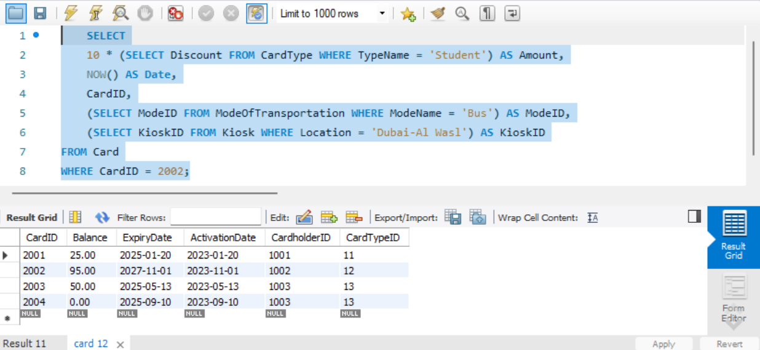

SELECT Cardholder.Name, Card.CardID, Card.Balance

FROM Card

INNER JOIN Cardholder ON Card.CardholderID = Cardholder.CardholderID;

SELECT *

FROM Card

WHERE Balance = (SELECT MAX(Balance) FROM Card);

SELECT

k.Location AS KioskLocation,

DATE(t.Date) AS TransactionDate,

SUM(t.Amount) AS TotalTransactionAmount,

SUM(tt.Amount) AS TotalTopUpAmount

FROM

Transaction t

JOIN

 Kiosk k ON t.KioskID = k.KioskID

LEFT JOIN

TopUpTransaction tt ON t.KioskID = tt.KioskID AND DATE(t.Date) = DATE(tt.Date)

GROUP BY

k.Location, DATE(t.Date);

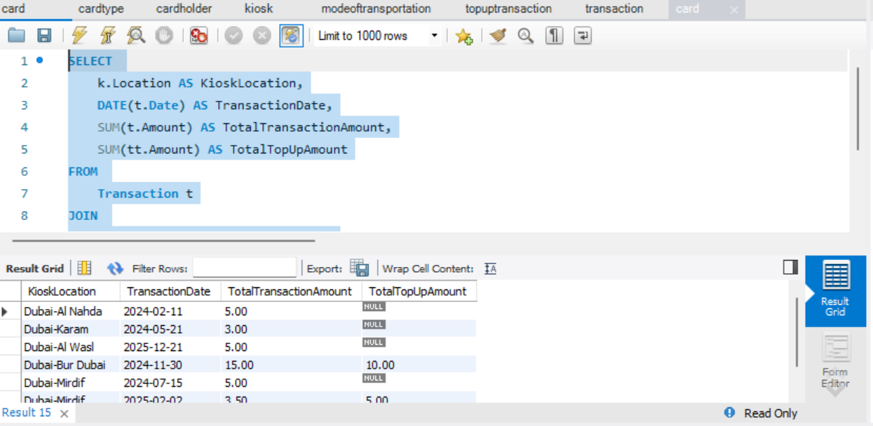

CREATE DEFINER=root@localhost PROCEDURE TopUpCard(

    IN p_CardID INT,

    IN p_Amount DECIMAL(10, 2),

    IN p_KioskID INT

)

BEGIN

    UPDATE Card

    SET Balance = Balance + p_Amount

    WHERE CardID = p_CardID;

    INSERT INTO TopUpTransaction (Amount, CardID, KioskID)

    VALUES (p_Amount, p_CardID, p_KioskID);

END

CALL TopUpCard(2003, 50, 71)

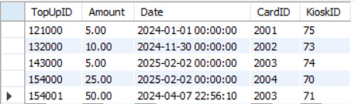

SELECT

    ModeName,

    (SELECT COUNT(*) FROM Transaction WHERE Transaction.ModeID = ModeOfTransportation.ModeID) AS TransactionCount,

    (SELECT SUM(Amount) FROM Transaction WHERE Transaction.ModeID = ModeOfTransportation.ModeID) AS TotalAmount

FROM

    ModeOfTransportation

ALTER TABLE Card

DROP FOREIGN KEY card_ibfk_1,

DROP FOREIGN KEY card_ibfk_2,

ADD CONSTRAINT FK_Card_CardType FOREIGN KEY (CardTypeID) REFERENCES CardType(CardTypeID) ON DELETE CASCADE,

ADD CONSTRAINT FK_Card_Cardholder FOREIGN KEY (CardholderID) REFERENCES Cardholder(CardholderID) ON DELETE CASCADE;

-- Update Transaction table with ON DELETE CASCADE

ALTER TABLE Transaction

DROP FOREIGN KEY transaction_ibfk_1,

DROP FOREIGN KEY transaction_ibfk_2,

DROP FOREIGN KEY transaction_ibfk_3,

ADD CONSTRAINT FK_Transaction_Card FOREIGN KEY (CardID) REFERENCES Card(CardID) ON DELETE CASCADE,

ADD CONSTRAINT FK_Transaction_Mode FOREIGN KEY (ModeID) REFERENCES ModeOfTransportation(ModeID),

ADD CONSTRAINT FK_Transaction_Kiosk FOREIGN KEY (KioskID) REFERENCES Kiosk(KioskID);

ALTER TABLE TopUpTransaction

DROP FOREIGN KEY topuptransaction_ibfk_1,

DROP FOREIGN KEY topuptransaction_ibfk_2,

ADD CONSTRAINT FK_TopUpTransaction_Kiosk

FOREIGN KEY (KioskID) REFERENCES Kiosk(KioskID) ON DELETE CASCADE,

ADD CONSTRAINT FK_TopUpTransaction_Card

FOREIGN KEY (CardID) REFERENCES Card(CardID) ON DELETE CASCADE;

DELETE FROM cardholder where cardholderid = "1002";

